[Library vs. Framework?](https://www.programcreek.com/2011/09/what-is-the-difference-between-a-java-library-and-a-framework/)

The key difference between a library and a framework is "Inversion of Control". When you call a method from a library, you are in control. But with a framework, the control is inverted: the framework calls you.

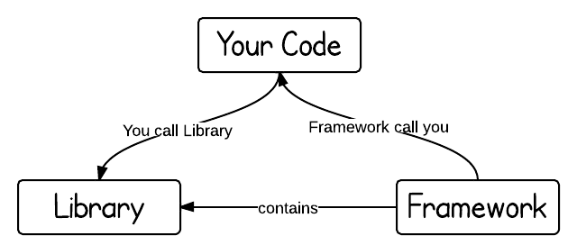

Both libraries and frameworks are reusable code written by someone else.

A library is like going to Ikea. You already have a home, but you need a bit of help with furniture. You don’t feel like making your own table from scratch. Ikea allows you to pick and choose different things to go in your home. You are in control.

A framework, on the other hand, is like building a model home. You have a set of blueprints and a few limited choices when it comes to architecture and design. Ultimately, the contractor and blueprint are in control. And they will let you know when and where you can provide your input.

When you use a library, you are in charge of the flow of the application. You are choosing when and where to call the library. When you use a framework, the framework is in charge of the flow. It provides some places for you to plug in your code, but it calls the code you plugged in as needed.

DLL Hell

**Introduction**Before some time, if we install an application then dll of that application get stored in the registry, then if we install other application that has same name .dll  that means previously installed .dll get overwrite by the same name new .dll. Ok for newly installed application but previously installed application cant get execute further. This is big problem in context of version of same application. This is Dell-Hell problem.  
OR  
Dll Hell refers to a set of problems caused when multiple applications attempt to share a common component like a dynamic link library (DLL).The reason for this issue was that the version information about the different components of an application was not recorded by the system.  
  
**Solution of Dll-Hell Problem**  
This problem of dynamic link library (.dll) is resolved through Versioning.  
 **Versioning:**Versioning is the technique to provide version to the .dll to prevent them from replacement. GAC (Global assembly cache) is the separate memory like cache it is used to remove load form operating system.

1.By default, HTML elements on an ASP.NET Web page are not available to the server. These components are treated as simple text and pass through to the browser. We can convert an HTML element to server control by adding a **runat="server"** and an **id** attribute to the component.

2. All the HTML Server controls can be accessed through the **Request** object.

3.To perform validation, ASP.NET provides controls that automatically check user input and require no code. We can also create custom validation for our application.